FSAE Tyre Data
V1.0

Introduction 1
General Data 2
Orientation 2
Stability Rig Schematic 3
Pacejka ’96 Model 4

Introduction

Please find the ‘Stab Rig’ data, static and dynamic spring rate data as well as general information regarding the Avon Tyres FSAE (formula student) tyre.

This document should be read in conjunction with 3 other files:-
Stab front.xls The stabrig response for the front tyre.
Stab rear.xls The stabrig response for the rear tyre.
Spring rates.xls Static and dynamic (rolling) spring rate data.

General Data

 | Front | Rear
Size | 6.2/20.0-13 | 7.2/20.0-13
Spec Number | 9241 | 9760
Rim Size | 6.0J x 13 | 6.0J x 13
Overall Diameter | 522 mm | 521 mm
Tread Width | 155 mm | 180 mm
Section Width | 183 mm | 229 mm

The above dimensions are for new tyres; used tyres will grow depending on use.

Please note that metal valve caps are generally supplied and are to be used at all times to avoid potentially dangerous unintentional pressure loss.
Cross ply tyres should always be overinflated and then dropped to the correct pressure to ensure a consistent diameter no matter what pressure the beads ‘pop’ on at. The above sizes were achieved on new tyres inflated to 55 psi and then dropped to 22 psi. Some variations are inevitable with cross-ply tyres however.

Orientation

In order to respect the tread joint that is inevitable in the manufacture of racing tyres, tyres should be fitted such that the orientation of the predominant forces do not work to open the joint or ‘splice’. The service crew will fit all tyres in sets and they mark up the tyres with their direction of orientation. There will be a spec number and barcode on only ONE sidewall of each tyre. If for any reason the markings are removed, use the following guide to establish the correct direction of rotation:-

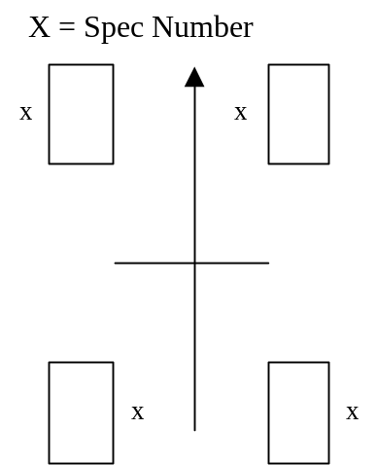

Stability Rig Schematic

A schematic diagram of the Stability rig used to generate the cornering force against slip angle, and self aligning torque against slip angle graphs.

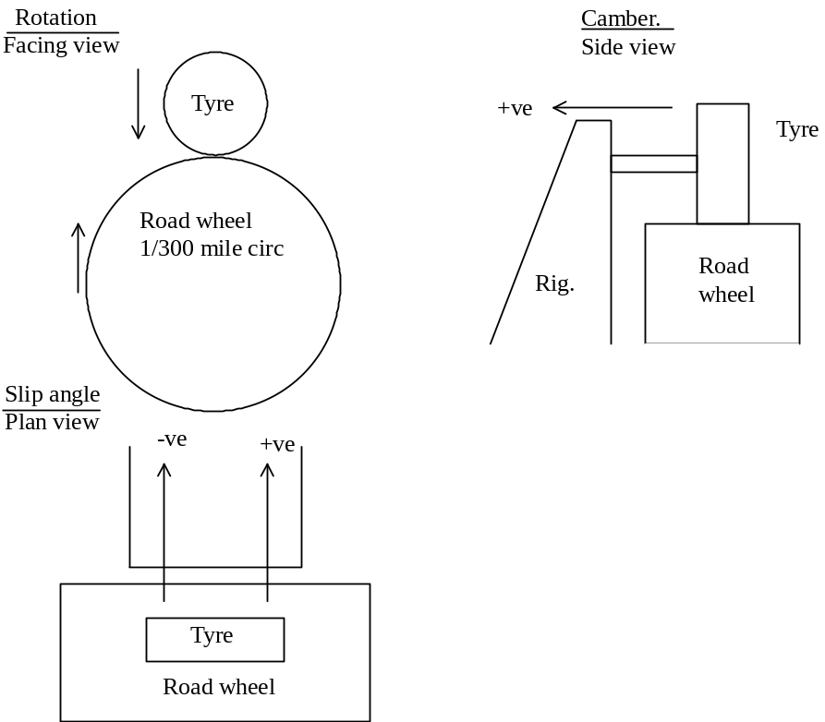

For the purposes of the Pacejka Model creation, all values from the original stabrig data were converted to Newtons. All angular measurements are in degrees (°). A positive vertical force was considered to be downwards. A positive slip angle was considered to be as if the tyre was turning left.

Pacejka ’96 Model

 | Slick Front | Slick Rear
[VERTICAL]
FNOMIN = | 2378.134018 | 2768.052344

[ALIGNING COEFFICIENTS]
QBZ1 = | 0 | 0
QBZ2 = | 0 | 0
QBZ3 = | 0 | 0
QBZ4 = | 0 | 0
QBZ5 = | 0 | 0
QBZ9 = | 0 | 0
QCZ1 = | 0 | 0
QDZ1 = | 0 | 0
QDZ2 = | 0 | 0
QDZ3 = | 0 | 0
QDZ4 = | 0 | 0
QDZ6 = | 0 | 0
QDZ7 = | 0 | 0
QDZ8 = | 0 | 0
QDZ9 = | 0 | 0
QEZ1 = | 0 | 0
QEZ2 = | 0 | 0
QEZ3 = | 0 | 0
QEZ4 = | 0 | 0
QEZ5 = | 0 | 0
QHZ1 = | 0 | 0
QHZ2 = | 0 | 0
QHZ3 = | 0 | 0
QHZ4 = | 0 | 0

[LATERAL COEFFICIENTS]
PCY1 = | 0.9539170 | 0.575992
PDY1 = | -1.1368650 | -1.647224
PDY2 = | 0.4689010 | 0.551853
PDY3 = | -5.2737330 | -3.584777
PEY1 = | -0.2999010 | -0.201334
PEY2 = | 0.8782960 | 0.478630
PEY3 = | -0.2283970 | -0.147912
PEY4 = | -7.3951333 | -8.693874
PKY1 = | -11.8621944 | -11.287945
PKY2 = | 1.2972245 | 0.882138
PKY3 = | 0.1856351 | 0.201026
PHY1 = | 0.0045202 | 0.003213
PHY2 = | -0.0007918 | -0.000304
PHY3 = | 0.0438000 | 0.035342
PVY1 = | 0.1338810 | 0.017493
PVY2 = | -0.1655041 | -0.076771
PVY3 = | -0.0526262 | -0.166538
PVY4 = | -0.8147694 | -0.222133

[LONGITUDINAL COEFFICIENTS]
PCX1 = | 0 | 0
PDX1 = | 0 | 0
PDX2 = | 0 | 0
PEX1 = | 0 | 0
PEX2 = | 0 | 0
PEX3 = | 0 | 0
PEX4 = | 0 | 0
PKX1 = | 0 | 0
PKX2 = | 0 | 0
PKX3 = | 0 | 0
PHX1 = | 0 | 0
PHX2 = | 0 | 0
PVX1 = | 0 | 0
PVX2 = | 0 | 0

[DATA]
CAMBER = | 1.5 | 0.5

